На личный ноутбук с Windows Home 11 установлены WSL2 и Docker с ОС Ubuntu

# Развёртывание и базовая конфигурация single-node

1. В Docker по инструкции [https://docs.google.com/document/d/1VP0fLm0D4quYyMj6cnwp0YQH5Bovx6vpDKfNCheaRtk/edit?tab=t.0#heading=h.hj6vwzasl1s6](https://docs.google.com/document/d/1VP0fLm0D4quYyMj6cnwp0YQH5Bovx6vpDKfNCheaRtk/edit?tab=t.0" \l "heading=h.hj6vwzasl1s6) добавлен образ и запущен контейнер с Greenplum DB. Порт для контейнера указан 5433, т.к. На порту 5432 у меня стоит PostreSQL.
2. Запущен GP из контейнера.

sh-4.4# su gpadmin

[gpadmin@64f3afcefe8b /]$ gpstart

20250429:12:35:55:000123 gpstart:64f3afcefe8b:gpadmin-[INFO]:-Starting gpstart with args:

20250429:12:35:55:000123 gpstart:64f3afcefe8b:gpadmin-[INFO]:-Gathering information and validating the environment...

20250429:12:35:55:000123 gpstart:64f3afcefe8b:gpadmin-[INFO]:-Greenplum Binary Version: 'postgres (Greenplum Database) 6.21.0 build commit:d0087e3b24c54d203ca8bb315559205f13cd6393 Open Source'

20250429:12:35:55:000123 gpstart:64f3afcefe8b:gpadmin-[INFO]:-Greenplum Catalog Version: '301908232'

20250429:12:35:55:000123 gpstart:64f3afcefe8b:gpadmin-[WARNING]:-postmaster.pid file exists on Master, checking if recovery startup required

20250429:12:35:55:000123 gpstart:64f3afcefe8b:gpadmin-[INFO]:-Commencing recovery startup checks

20250429:12:35:55:000123 gpstart:64f3afcefe8b:gpadmin-[INFO]:-Have lock file /tmp/.s.PGSQL.5432 but no process running on port 5432

20250429:12:35:55:000123 gpstart:64f3afcefe8b:gpadmin-[INFO]:-No Master instance process, entering recovery startup mode

20250429:12:35:55:000123 gpstart:64f3afcefe8b:gpadmin-[INFO]:-Clearing Master instance lock files

20250429:12:35:55:000123 gpstart:64f3afcefe8b:gpadmin-[INFO]:-Clearing Master instance pid file

20250429:12:35:55:000123 gpstart:64f3afcefe8b:gpadmin-[INFO]:-Starting Master instance in admin mode

20250429:12:35:55:000123 gpstart:64f3afcefe8b:gpadmin-[INFO]:-Obtaining Greenplum Master catalog information

20250429:12:35:55:000123 gpstart:64f3afcefe8b:gpadmin-[INFO]:-Obtaining Segment details from master...

20250429:12:35:55:000123 gpstart:64f3afcefe8b:gpadmin-[INFO]:-Setting new master era

20250429:12:35:55:000123 gpstart:64f3afcefe8b:gpadmin-[INFO]:-Commencing forced instance shutdown

20250429:12:35:55:000123 gpstart:64f3afcefe8b:gpadmin-[INFO]:-Starting Master instance in admin mode

20250429:12:35:55:000123 gpstart:64f3afcefe8b:gpadmin-[INFO]:-Obtaining Greenplum Master catalog information

20250429:12:35:55:000123 gpstart:64f3afcefe8b:gpadmin-[INFO]:-Obtaining Segment details from master...

20250429:12:35:55:000123 gpstart:64f3afcefe8b:gpadmin-[INFO]:-Setting new master era

20250429:12:35:55:000123 gpstart:64f3afcefe8b:gpadmin-[INFO]:-Master Started...

20250429:12:35:55:000123 gpstart:64f3afcefe8b:gpadmin-[INFO]:-Shutting down master

20250429:12:35:56:000123 gpstart:64f3afcefe8b:gpadmin-[INFO]:---------------------------

20250429:12:35:56:000123 gpstart:64f3afcefe8b:gpadmin-[INFO]:-Master instance parameters

20250429:12:35:56:000123 gpstart:64f3afcefe8b:gpadmin-[INFO]:---------------------------

20250429:12:35:56:000123 gpstart:64f3afcefe8b:gpadmin-[INFO]:-Database = template1

20250429:12:35:56:000123 gpstart:64f3afcefe8b:gpadmin-[INFO]:-Master Port = 5432

20250429:12:35:56:000123 gpstart:64f3afcefe8b:gpadmin-[INFO]:-Master directory = /gpdb/gpmaster/gpseg-1

20250429:12:35:56:000123 gpstart:64f3afcefe8b:gpadmin-[INFO]:-Timeout = 600 seconds

20250429:12:35:56:000123 gpstart:64f3afcefe8b:gpadmin-[INFO]:-Master standby = Off

20250429:12:35:56:000123 gpstart:64f3afcefe8b:gpadmin-[INFO]:---------------------------------------

20250429:12:35:56:000123 gpstart:64f3afcefe8b:gpadmin-[INFO]:-Segment instances that will be started

20250429:12:35:56:000123 gpstart:64f3afcefe8b:gpadmin-[INFO]:---------------------------------------

20250429:12:35:56:000123 gpstart:64f3afcefe8b:gpadmin-[INFO]:- Host Datadir Port

20250429:12:35:56:000123 gpstart:64f3afcefe8b:gpadmin-[INFO]:- localhost /gpdb/gpdata1/gpseg0 6000

20250429:12:35:56:000123 gpstart:64f3afcefe8b:gpadmin-[INFO]:- localhost /gpdb/gpdata2/gpseg1 6001

20250429:12:35:56:000123 gpstart:64f3afcefe8b:gpadmin-[INFO]:- localhost /gpdb/gpdata3/gpseg2 6002

20250429:12:35:56:000123 gpstart:64f3afcefe8b:gpadmin-[INFO]:- localhost /gpdb/gpdata4/gpseg3 6003

Continue with Greenplum instance startup Yy|Nn (default=N):

> Y

20250429:12:35:59:000123 gpstart:64f3afcefe8b:gpadmin-[INFO]:-Commencing parallel segment instance startup, please wait...

20250429:12:36:00:000123 gpstart:64f3afcefe8b:gpadmin-[INFO]:-Process results...

20250429:12:36:00:000123 gpstart:64f3afcefe8b:gpadmin-[INFO]:-----------------------------------------------------

20250429:12:36:00:000123 gpstart:64f3afcefe8b:gpadmin-[INFO]:- Successful segment starts = 4

20250429:12:36:00:000123 gpstart:64f3afcefe8b:gpadmin-[INFO]:- Failed segment starts = 0

20250429:12:36:00:000123 gpstart:64f3afcefe8b:gpadmin-[INFO]:- Skipped segment starts (segments are marked down in configuration) = 0

20250429:12:36:00:000123 gpstart:64f3afcefe8b:gpadmin-[INFO]:-----------------------------------------------------

20250429:12:36:00:000123 gpstart:64f3afcefe8b:gpadmin-[INFO]:-Successfully started 4 of 4 segment instances

20250429:12:36:00:000123 gpstart:64f3afcefe8b:gpadmin-[INFO]:-----------------------------------------------------

20250429:12:36:00:000123 gpstart:64f3afcefe8b:gpadmin-[INFO]:-Starting Master instance localhost directory /gpdb/gpmaster/gpseg-1

20250429:12:36:00:000123 gpstart:64f3afcefe8b:gpadmin-[INFO]:-Command pg_ctl reports Master localhost instance active

20250429:12:36:00:000123 gpstart:64f3afcefe8b:gpadmin-[INFO]:-Connecting to dbname='template1' connect_timeout=15

20250429:12:36:00:000123 gpstart:64f3afcefe8b:gpadmin-[INFO]:-No standby master configured. skipping...

20250429:12:36:00:000123 gpstart:64f3afcefe8b:gpadmin-[INFO]:-Database successfully started

4. Подключение к БД из Dbeaver

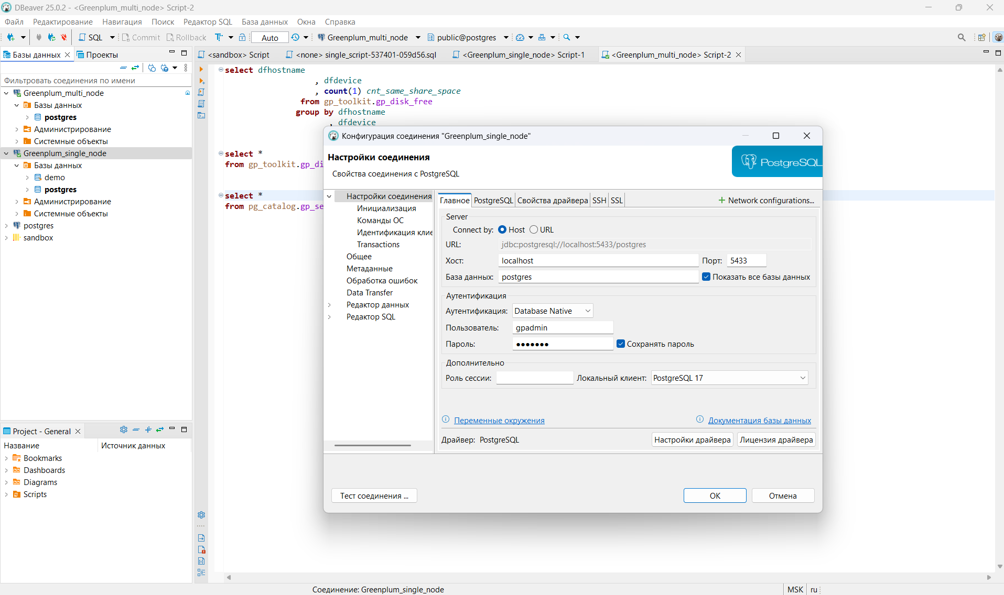

# Развёртывание и базовая конфигурация multi-node

1. В Docker по инструкции добавлен образ и запущен контейнер с Greenplum DB.

<https://t.me/c/2650491605/50>

*Для того что бы можно было воспользоваться в докер контейнере необходимо скачать репозиторий dev_adgp (https://github.com/sql-mpp-gp/dev_adgp) и запустить по инструкции docker образ*

*git clone https://github.com/sql-mpp-gp/dev_adgp*

*Create docker image:*

*docker build -t gpdb .*

*Run docker image:*

*docker run -v ./gpdemo:/tmp/gpdb/gpdemo -d -p2222:22 gpdb*

*Connect to docker image:*

*ssh gpadmin@localhost -p 2222*

*(input yes and password gpadmin)*

*2. Выполнена сборка кластера предварительно пришлось додать права командой "chmod 777 -R /tmp/gpdb/" после запуска контейнера*

*3. Запущен кластер*

*PS C:\git\dev_adgp> docker run -v ./gpdemo:/tmp/gpdb/gpdemo -d -p2222:22 gpdb*

*1538594eb3b6633d4eb31c6aeebf3dfe116fb58ec07713610a818289e759f1fc*

*PS C:\git\dev_adgp> ssh gpadmin@localhost -p 2222*

*gpadmin@localhost's password:*

*Welcome to Ubuntu 18.04 LTS (GNU/Linux 5.15.167.4-microsoft-standard-WSL2 x86_64)*

*\* Documentation: https://help.ubuntu.com*

*\* Management: https://landscape.canonical.com*

*\* Support: https://ubuntu.com/advantage*

*The programs included with the Ubuntu system are free software;*

*the exact distribution terms for each program are described in the*

*individual files in /usr/share/doc/*/copyright.*

*Ubuntu comes with ABSOLUTELY NO WARRANTY, to the extent permitted by*

*applicable law.*

*To run a command as administrator (user "root"), use "sudo <command>".*

*See "man sudo_root" for details.*

*GPADMIN LOADED =======================================*

*gpadmin@1538594eb3b6:/tmp/gpdb/gpAux/gpdemo$ make cluster*

*======================================================================*

*______ _____ ______ _______ _______ _____*

*| ____ |_____] | \ |______ | | | | |*

*|_____| | |_____/ |______ | | | |_____|*

*----------------------------------------------------------------------*

*This is a demo of the Greenplum Database system. We will create*

*a cluster installation with master and 6 segment instances*

*(3 primary & 3 mirror).*

*GPHOME ................. : /usr/local/gpdb*

*MASTER_DATA_DIRECTORY .. : /tmp/gpdb/gpdemo/qddir/demoDataDir-1*

*MASTER PORT (PGPORT) ... : 6000*

*STANDBY PORT ........... : 6001*

*SEGMENT PORTS .......... : 6002 6003 6004 6005 6006 6007*

*NOTE(s):*

*\* The DB ports identified above must be available for use.*

*\* An environment file gpdemo-env.sh has been created for your use.*

*======================================================================*

*rm: cannot remove '/tmp/gpdb/gpdemo': Device or resource busy*

*[1538594eb3b6] rm: cannot remove '/tmp/gpdb/gpdemo': Device or resource busy*

*mkdir: cannot create directory '/tmp/gpdb/gpdemo': File exists*

*[1538594eb3b6]*

*[1538594eb3b6]*

*[1538594eb3b6]*

*[1538594eb3b6]*

*[1538594eb3b6]*

*[1538594eb3b6]*

*grep: clusterConfigPostgresAddonsFile: No such file or directory*

*======================================================================*

*CLUSTER_CONFIG_POSTGRES_ADDONS: clusterConfigPostgresAddonsFile*

*----------------------------------------------------------------------*

*fsync=off*

*======================================================================*

*==========================================================================================*

*executing:*

*/usr/local/gpdb/bin/gpinitsystem -a -c clusterConfigFile -l /tmp/gpdb/gpdemo/gpAdminLogs -p clusterConfigPostgresAddonsFile -s 1538594eb3b6 -P 6001 -S /tmp/gpdb/gpdemo/standby ""*

*==========================================================================================*

*20250429:09:03:37:000657 gpinitsystem:1538594eb3b6:gpadmin-[INFO]:-Checking configuration parameters, please wait...*

*20250429:09:03:37:000657 gpinitsystem:1538594eb3b6:gpadmin-[INFO]:-Reading Greenplum configuration file clusterConfigFile*

*20250429:09:03:37:000657 gpinitsystem:1538594eb3b6:gpadmin-[INFO]:-Locale has not been set in clusterConfigFile, will set to default value*

*20250429:09:03:37:000657 gpinitsystem:1538594eb3b6:gpadmin-[INFO]:-Locale set to en_US.utf8*

*20250429:09:03:37:000657 gpinitsystem:1538594eb3b6:gpadmin-[INFO]:-No DATABASE_NAME set, will exit following template1 updates*

*20250429:09:03:37:000657 gpinitsystem:1538594eb3b6:gpadmin-[INFO]:-MASTER_MAX_CONNECT not set, will set to default value 150*

*20250429:09:03:37:000657 gpinitsystem:1538594eb3b6:gpadmin-[INFO]:-Detected a single host GPDB array build, reducing value of BATCH_DEFAULT from 60 to 4*

*20250429:09:03:37:000657 gpinitsystem:1538594eb3b6:gpadmin-[WARN]:-Master open file limit is 1024 should be >= 65535*

*20250429:09:03:37:000657 gpinitsystem:1538594eb3b6:gpadmin-[INFO]:-Master IP address array = 172.17.0.2*

*20250429:09:03:37:000657 gpinitsystem:1538594eb3b6:gpadmin-[INFO]:-Standby IP address array = 172.17.0.2*

*20250429:09:03:37:000657 gpinitsystem:1538594eb3b6:gpadmin-[WARN]:-Standby Master open file limit is 1024 should be >= 65535*

*20250429:09:03:37:000657 gpinitsystem:1538594eb3b6:gpadmin-[INFO]:-Checking configuration parameters, Completed*

*20250429:09:03:37:000657 gpinitsystem:1538594eb3b6:gpadmin-[INFO]:-Commencing multi-home checks, please wait...*

*.*

*20250429:09:03:37:000657 gpinitsystem:1538594eb3b6:gpadmin-[INFO]:-Configuring build for standard array*

*20250429:09:03:37:000657 gpinitsystem:1538594eb3b6:gpadmin-[INFO]:-Commencing multi-home checks, Completed*

*20250429:09:03:37:000657 gpinitsystem:1538594eb3b6:gpadmin-[INFO]:-Building primary segment instance array, please wait...*

*...*

*20250429:09:03:37:000657 gpinitsystem:1538594eb3b6:gpadmin-[INFO]:-Building group mirror array type , please wait...*

*...*

*20250429:09:03:37:000657 gpinitsystem:1538594eb3b6:gpadmin-[INFO]:-Checking Master host*

*20250429:09:03:37:000657 gpinitsystem:1538594eb3b6:gpadmin-[INFO]:-Checking new segment hosts, please wait...*

*20250429:09:03:37:000657 gpinitsystem:1538594eb3b6:gpadmin-[WARN]:-Host 1538594eb3b6 open files limit is 1024 should be >= 65535*

*......20250429:09:03:38:000657 gpinitsystem:1538594eb3b6:gpadmin-[WARN]:-Host 1538594eb3b6 open files limit is 1024 should be >= 65535*

*20250429:09:03:38:000657 gpinitsystem:1538594eb3b6:gpadmin-[INFO]:-Checking new segment hosts, Completed*

*20250429:09:03:38:000657 gpinitsystem:1538594eb3b6:gpadmin-[INFO]:-Building the Master instance database, please wait...*

*20250429:09:03:41:000657 gpinitsystem:1538594eb3b6:gpadmin-[INFO]:-Starting the Master in admin mode*

*20250429:09:03:41:000657 gpinitsystem:1538594eb3b6:gpadmin-[INFO]:-Commencing parallel build of primary segment instances*

*20250429:09:03:41:000657 gpinitsystem:1538594eb3b6:gpadmin-[INFO]:-Spawning parallel processes batch [1], please wait...*

*...*

*20250429:09:03:41:000657 gpinitsystem:1538594eb3b6:gpadmin-[INFO]:-Waiting for parallel processes batch [1], please wait...*

*...........*

*20250429:09:03:52:000657 gpinitsystem:1538594eb3b6:gpadmin-[INFO]:------------------------------------------------*

*20250429:09:03:52:000657 gpinitsystem:1538594eb3b6:gpadmin-[INFO]:-Parallel process exit status*

*20250429:09:03:52:000657 gpinitsystem:1538594eb3b6:gpadmin-[INFO]:------------------------------------------------*

*20250429:09:03:52:000657 gpinitsystem:1538594eb3b6:gpadmin-[INFO]:-Total processes marked as completed = 3*

*20250429:09:03:52:000657 gpinitsystem:1538594eb3b6:gpadmin-[INFO]:-Total processes marked as killed = 0*

*20250429:09:03:52:000657 gpinitsystem:1538594eb3b6:gpadmin-[INFO]:-Total processes marked as failed = 0*

*20250429:09:03:52:000657 gpinitsystem:1538594eb3b6:gpadmin-[INFO]:------------------------------------------------*

*20250429:09:03:52:000657 gpinitsystem:1538594eb3b6:gpadmin-[INFO]:-Removing back out file*

*20250429:09:03:52:000657 gpinitsystem:1538594eb3b6:gpadmin-[INFO]:-No errors generated from parallel processes*

*20250429:09:03:52:000657 gpinitsystem:1538594eb3b6:gpadmin-[INFO]:-Restarting the Greenplum instance in production mode*

*20250429:09:03:52:006331 gpstop:1538594eb3b6:gpadmin-[INFO]:-Starting gpstop with args: -a -l /tmp/gpdb/gpdemo/gpAdminLogs -m -d /tmp/gpdb/gpdemo/qddir/demoDataDir-1*

*20250429:09:03:52:006331 gpstop:1538594eb3b6:gpadmin-[INFO]:-Gathering information and validating the environment...*

*20250429:09:03:52:006331 gpstop:1538594eb3b6:gpadmin-[INFO]:-Obtaining Greenplum Master catalog information*

*20250429:09:03:52:006331 gpstop:1538594eb3b6:gpadmin-[INFO]:-Obtaining Segment details from master...*

*20250429:09:03:52:006331 gpstop:1538594eb3b6:gpadmin-[INFO]:-Greenplum Version: 'postgres (Greenplum Database) 6.27.1_arenadata59+dev.1.gcbb3338b74 build dev'*

*20250429:09:03:52:006331 gpstop:1538594eb3b6:gpadmin-[INFO]:-Commencing Master instance shutdown with mode='smart'*

*20250429:09:03:52:006331 gpstop:1538594eb3b6:gpadmin-[INFO]:-Master segment instance directory=/tmp/gpdb/gpdemo/qddir/demoDataDir-1*

*20250429:09:03:53:006331 gpstop:1538594eb3b6:gpadmin-[INFO]:-Stopping master segment and waiting for user connections to finish ...*

*server shutting down*

*20250429:09:03:54:006331 gpstop:1538594eb3b6:gpadmin-[INFO]:-Attempting forceful termination of any leftover master process*

*20250429:09:03:54:006331 gpstop:1538594eb3b6:gpadmin-[INFO]:-Terminating processes for segment /tmp/gpdb/gpdemo/qddir/demoDataDir-1*

*20250429:09:03:55:006576 gpstart:1538594eb3b6:gpadmin-[INFO]:-Starting gpstart with args: -a -l /tmp/gpdb/gpdemo/gpAdminLogs -d /tmp/gpdb/gpdemo/qddir/demoDataDir-1*

*20250429:09:03:55:006576 gpstart:1538594eb3b6:gpadmin-[INFO]:-Gathering information and validating the environment...*

*20250429:09:03:55:006576 gpstart:1538594eb3b6:gpadmin-[INFO]:-Greenplum Binary Version: 'postgres (Greenplum Database) 6.27.1_arenadata59+dev.1.gcbb3338b74 build dev'*

*20250429:09:03:55:006576 gpstart:1538594eb3b6:gpadmin-[INFO]:-Greenplum Catalog Version: '301908232'*

*20250429:09:03:55:006576 gpstart:1538594eb3b6:gpadmin-[INFO]:-Starting Master instance in admin mode*

*20250429:09:03:55:006576 gpstart:1538594eb3b6:gpadmin-[INFO]:-Obtaining Greenplum Master catalog information*

*20250429:09:03:55:006576 gpstart:1538594eb3b6:gpadmin-[INFO]:-Obtaining Segment details from master...*

*20250429:09:03:55:006576 gpstart:1538594eb3b6:gpadmin-[INFO]:-Setting new master era*

*20250429:09:03:55:006576 gpstart:1538594eb3b6:gpadmin-[INFO]:-Master Started...*

*20250429:09:03:56:006576 gpstart:1538594eb3b6:gpadmin-[INFO]:-Shutting down master*

*20250429:09:03:58:006576 gpstart:1538594eb3b6:gpadmin-[INFO]:-Commencing parallel segment instance startup, please wait...*

*20250429:09:03:58:006576 gpstart:1538594eb3b6:gpadmin-[INFO]:-Process results...*

*20250429:09:03:58:006576 gpstart:1538594eb3b6:gpadmin-[INFO]:-----------------------------------------------------*

*20250429:09:03:58:006576 gpstart:1538594eb3b6:gpadmin-[INFO]:- Successful segment starts = 3*

*20250429:09:03:58:006576 gpstart:1538594eb3b6:gpadmin-[INFO]:- Failed segment starts = 0*

*20250429:09:03:58:006576 gpstart:1538594eb3b6:gpadmin-[INFO]:- Skipped segment starts (segments are marked down in configuration) = 0*

*20250429:09:03:58:006576 gpstart:1538594eb3b6:gpadmin-[INFO]:-----------------------------------------------------*

*20250429:09:03:58:006576 gpstart:1538594eb3b6:gpadmin-[INFO]:-Successfully started 3 of 3 segment instances*

*20250429:09:03:58:006576 gpstart:1538594eb3b6:gpadmin-[INFO]:-----------------------------------------------------*

*20250429:09:03:58:006576 gpstart:1538594eb3b6:gpadmin-[INFO]:-Starting Master instance 1538594eb3b6 directory /tmp/gpdb/gpdemo/qddir/demoDataDir-1*

*20250429:09:03:59:006576 gpstart:1538594eb3b6:gpadmin-[INFO]:-Command pg_ctl reports Master 1538594eb3b6 instance active*

*20250429:09:03:59:006576 gpstart:1538594eb3b6:gpadmin-[INFO]:-Connecting to dbname='template1' connect_timeout=15*

*20250429:09:03:59:006576 gpstart:1538594eb3b6:gpadmin-[INFO]:-No standby master configured. skipping...*

*20250429:09:03:59:006576 gpstart:1538594eb3b6:gpadmin-[INFO]:-Database successfully started*

*20250429:09:03:59:000657 gpinitsystem:1538594eb3b6:gpadmin-[INFO]:-Completed restart of Greenplum instance in production mode*

*20250429:09:03:59:000657 gpinitsystem:1538594eb3b6:gpadmin-[INFO]:-Commencing parallel build of mirror segment instances*

*20250429:09:03:59:000657 gpinitsystem:1538594eb3b6:gpadmin-[INFO]:-Spawning parallel processes batch [1], please wait...*

*...*

*20250429:09:03:59:000657 gpinitsystem:1538594eb3b6:gpadmin-[INFO]:-Waiting for parallel processes batch [1], please wait...*

*....*

*20250429:09:04:03:000657 gpinitsystem:1538594eb3b6:gpadmin-[INFO]:------------------------------------------------*

*20250429:09:04:03:000657 gpinitsystem:1538594eb3b6:gpadmin-[INFO]:-Parallel process exit status*

*20250429:09:04:03:000657 gpinitsystem:1538594eb3b6:gpadmin-[INFO]:------------------------------------------------*

*20250429:09:04:03:000657 gpinitsystem:1538594eb3b6:gpadmin-[INFO]:-Total processes marked as completed = 3*

*20250429:09:04:03:000657 gpinitsystem:1538594eb3b6:gpadmin-[INFO]:-Total processes marked as killed = 0*

*20250429:09:04:03:000657 gpinitsystem:1538594eb3b6:gpadmin-[INFO]:-Total processes marked as failed = 0*

*20250429:09:04:03:000657 gpinitsystem:1538594eb3b6:gpadmin-[INFO]:------------------------------------------------*

*20250429:09:04:03:000657 gpinitsystem:1538594eb3b6:gpadmin-[INFO]:-Starting initialization of standby master 1538594eb3b6*

*Operation: Cannot import modules. Please check that you have sourced greenplum_path.sh. Detail: No module named yaml*

*20250429:09:04:03:000657 gpinitsystem:1538594eb3b6:gpadmin-[WARN]:-Non-fatal issue with standby master initialization, check gpstate -f output*

*20250429:09:04:03:000657 gpinitsystem:1538594eb3b6:gpadmin-[INFO]:-Scanning utility log file for any warning messages*

*20250429:09:04:03:000657 gpinitsystem:1538594eb3b6:gpadmin-[WARN]:-\*\*\*\*\*\*\*\*\*\*\*\*\*\*\*\*\*\*\*\*\*\*\*\*\*\*\*\*\*\*\*\*\*\*\*\*\*\*\*\*\*\*\*\*\*\*\*\*\*\*\*\*\*\*\**

*20250429:09:04:03:000657 gpinitsystem:1538594eb3b6:gpadmin-[WARN]:-Scan of log file indicates that some warnings or errors*

*20250429:09:04:03:000657 gpinitsystem:1538594eb3b6:gpadmin-[WARN]:-were generated during the array creation*

*20250429:09:04:03:000657 gpinitsystem:1538594eb3b6:gpadmin-[INFO]:-Please review contents of log file*

*20250429:09:04:03:000657 gpinitsystem:1538594eb3b6:gpadmin-[INFO]:-/tmp/gpdb/gpdemo/gpAdminLogs/gpinitsystem_20250429.log*

*20250429:09:04:03:000657 gpinitsystem:1538594eb3b6:gpadmin-[INFO]:-To determine level of criticality*

*20250429:09:04:03:000657 gpinitsystem:1538594eb3b6:gpadmin-[WARN]:-\*\*\*\*\*\*\*\*\*\*\*\*\*\*\*\*\*\*\*\*\*\*\*\*\*\*\*\*\*\*\*\*\*\*\*\*\*\*\*\*\*\*\*\*\*\*\*\*\*\*\*\*\*\*\**

*20250429:09:04:03:000657 gpinitsystem:1538594eb3b6:gpadmin-[INFO]:-Greenplum Database instance successfully created*

*20250429:09:04:03:000657 gpinitsystem:1538594eb3b6:gpadmin-[INFO]:-------------------------------------------------------*

*20250429:09:04:03:000657 gpinitsystem:1538594eb3b6:gpadmin-[INFO]:-To complete the environment configuration, please*

*20250429:09:04:03:000657 gpinitsystem:1538594eb3b6:gpadmin-[INFO]:-update gpadmin .bashrc file with the following*

*20250429:09:04:03:000657 gpinitsystem:1538594eb3b6:gpadmin-[INFO]:-1. Ensure that the greenplum_path.sh file is sourced*

*20250429:09:04:03:000657 gpinitsystem:1538594eb3b6:gpadmin-[INFO]:-2. Add "export MASTER_DATA_DIRECTORY=/tmp/gpdb/gpdemo/qddir/demoDataDir-1"*

*20250429:09:04:03:000657 gpinitsystem:1538594eb3b6:gpadmin-[INFO]:- to access the Greenplum scripts for this instance:*

*20250429:09:04:03:000657 gpinitsystem:1538594eb3b6:gpadmin-[INFO]:- or, use -d /tmp/gpdb/gpdemo/qddir/demoDataDir-1 option for the Greenplum scripts*

*20250429:09:04:03:000657 gpinitsystem:1538594eb3b6:gpadmin-[INFO]:- Example gpstate -d /tmp/gpdb/gpdemo/qddir/demoDataDir-1*

*20250429:09:04:03:000657 gpinitsystem:1538594eb3b6:gpadmin-[INFO]:-Script log file = /tmp/gpdb/gpdemo/gpAdminLogs/gpinitsystem_20250429.log*

*20250429:09:04:03:000657 gpinitsystem:1538594eb3b6:gpadmin-[INFO]:-To remove instance, run gpdeletesystem utility*

*20250429:09:04:03:000657 gpinitsystem:1538594eb3b6:gpadmin-[INFO]:-Standby Master 1538594eb3b6 has been configured*

*20250429:09:04:03:000657 gpinitsystem:1538594eb3b6:gpadmin-[INFO]:-To activate the Standby Master Segment in the event of Master*

*20250429:09:04:03:000657 gpinitsystem:1538594eb3b6:gpadmin-[INFO]:-failure review options for gpactivatestandby*

*20250429:09:04:03:000657 gpinitsystem:1538594eb3b6:gpadmin-[INFO]:-------------------------------------------------------*

*20250429:09:04:03:000657 gpinitsystem:1538594eb3b6:gpadmin-[INFO]:-The Master /tmp/gpdb/gpdemo/qddir/demoDataDir-1/pg_hba.conf post gpinitsystem*

*20250429:09:04:03:000657 gpinitsystem:1538594eb3b6:gpadmin-[INFO]:-has been configured to allow all hosts within this new*

*20250429:09:04:03:000657 gpinitsystem:1538594eb3b6:gpadmin-[INFO]:-array to intercommunicate. Any hosts external to this*

*20250429:09:04:03:000657 gpinitsystem:1538594eb3b6:gpadmin-[INFO]:-new array must be explicitly added to this file*

*20250429:09:04:03:000657 gpinitsystem:1538594eb3b6:gpadmin-[INFO]:-Refer to the Greenplum Admin support guide which is*

*20250429:09:04:03:000657 gpinitsystem:1538594eb3b6:gpadmin-[INFO]:-located in the /usr/local/gpdb/docs directory*

*20250429:09:04:03:000657 gpinitsystem:1538594eb3b6:gpadmin-[INFO]:-------------------------------------------------------*

*========================================*

*gpinitsystem returned: 1*

*========================================*

*======================================================================*

*OPTIMIZER STATE*

*----------------------------------------------------------------------*

*Optimizer state .. : on*

*======================================================================*

*version*

*------------------------------------------------------------------------------------------------------------------------------------------------------------------------------------------------------------*

*PostgreSQL 9.4.26 (Greenplum Database 6.27.1_arenadata59+dev.1.gcbb3338b74 build dev) on x86_64-unknown-linux-gnu, compiled by gcc (Ubuntu 7.3.0-16ubuntu3) 7.3.0, 64-bit compiled on Jan 1 2025 23:04:39*

*(1 row)*

*optimizer*

*-----------*

*on*

*(1 row)*

*gp_opt_version*

*---------------------------------------------*

*GPOPT version: 4.0.0, Xerces version: 3.1.2*

*(1 row)*

*======================================================================*

4. Подключение к БД из Dbeaver

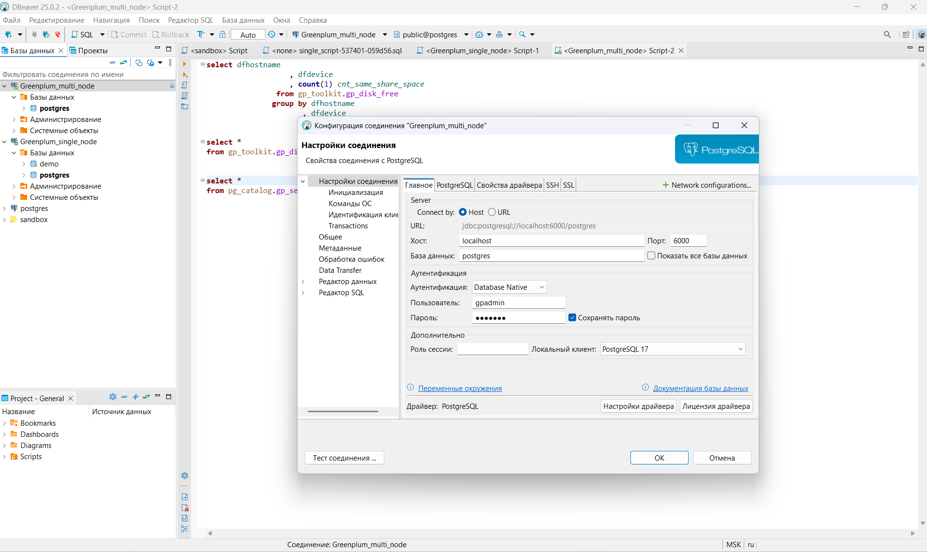

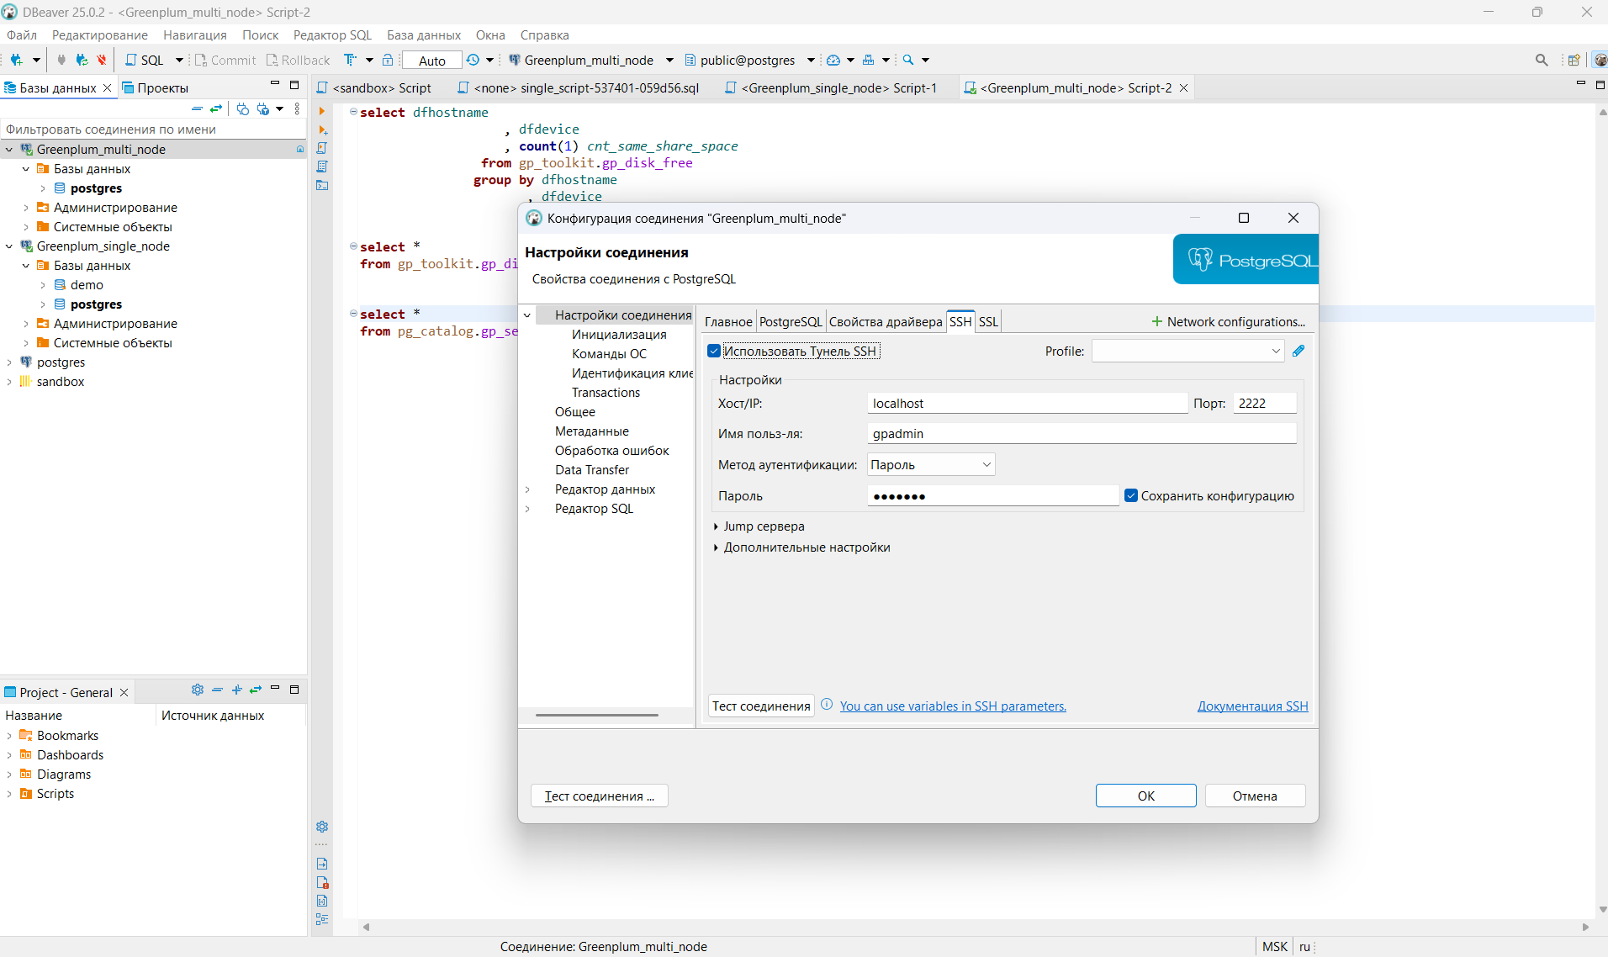

Скрин Docker

